WTMA LAB MANUAL – CSS PROGRAMS

Experiment – CSS Stylesheets & Animation

Program 1: Develop and demonstrate the usage of Inline, Internal and External style sheet using CSS

Aim
To design a simple web page and demonstrate the usage of:
- Inline CSS
- Internal CSSss
- External CSS

Software Required
- OS: Windows / Linux
- Editor: VS Code / Notepad++
- Browser: Chrome / Firefox

Theory
CSS (Cascading Style Sheets) is used to control presentation of HTML elements such as:
- Colors
- Fonts
- Layout
- Spacing
Types of CSS:
- Inline CSS – applied directly inside an HTML tag
- Internal CSS – written in <style> tag inside <head> section
- External CSS – written in a separate .css file and linked using <link> tag

Steps / Procedure

A) Inline CSS
- Open VS Code / Notepad++.
- Create a new file and save as inline.html.
- Write basic HTML structure.
- Apply CSS directly inside tags using the style="" attribute:
o Example: style="color: blue; text-align: center;"
- Save the file.
- Open inline.html in a browser (Chrome/Firefox).
- Verify that styles are applied inside individual elements.

B) Internal CSS
- Create a new file and save as internal.html.
- Write basic HTML structure.
- Inside <head> section, add <style> ... </style> block.
- Write CSS rules for elements like:
o body, h1, p, button
- Save the file.
- Open internal.html in browser.
- Verify that styles are applied through internal stylesheet.

C) External CSS
- Create a new file and save as external.html.
- Create another file and save as style.css in the same folder.
- In external.html, link CSS using:
- <link rel="stylesheet" href="style.css">
- In style.css, write the CSS rules for:
o body, h1, p, button
- Save both files.
- Open external.html in browser.
- Confirm webpage formatting is applied from external file.

Program Code
A) Inline CSS Example

File: inline.html
<!DOCTYPE html>
<html>
<head>
<title>Inline CSS Example</title>
</head>
<body>
<h1 style="color: blue; text-align: center;">WTMA Inline CSS</h1>

<p style="font-size: 18px; color: green;">
This paragraph is styled using Inline CSS.
</p>

<button style="background: orange; padding: 10px; border: none;">
Click Me
</button>
</body>
</html>

B) Internal CSS Example

File: internal.html
<!DOCTYPE html>
<html>
<head>
<title>Internal CSS Example</title>

<style> body { font-family: Arial; background-color: #f4f4f4;
}

h1 { color: darkred; text-align: center;
} p { font-size: 18px; color: navy; margin: 20px;
}

button { background-color: green; color: white; padding: 10px 15px; border: none; border-radius: 5px;
}
</style>
</head>
<body>
<h1>WTMA Internal CSS</h1>
<p>This content is styled using Internal CSS.</p>
<button>Submit</button>
</body>
</html>

C) External CSS Example

File 1: external.html
<!DOCTYPE html>
<html>
<head>
<title>External CSS Example</title>
<link rel="stylesheet" href="style.css">
</head>
<body>
<h1>WTMA External CSS</h1>
<p>This page uses External CSS file.</p>
<button>Login</button>
</body>
</html>
File 2: style.css body { font-family: Verdana; background-color: #e8f0ff;
}

h1 { color: purple; text-align: center; margin-top: 30px;
}

p { font-size: 18px; color: #333; margin: 20px;
}

button { background-color: #ff0066; color: white; padding: 10px 20px; border: none; border-radius: 6px;
}

Output
- Inline styles visible directly in HTML tags
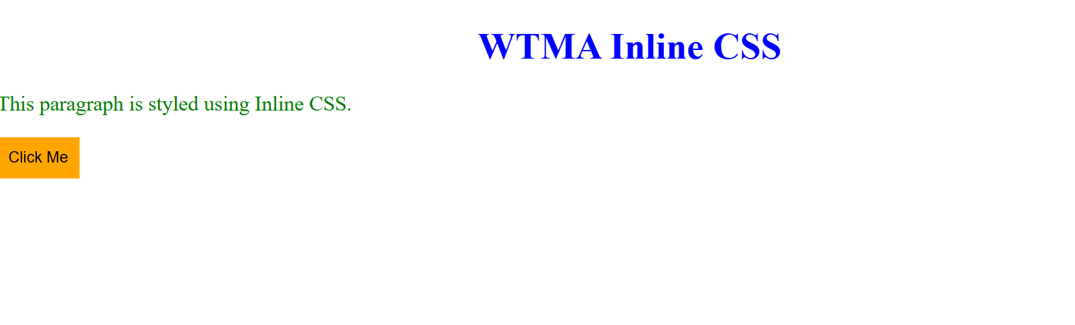
- Internal CSS applied through <style> section
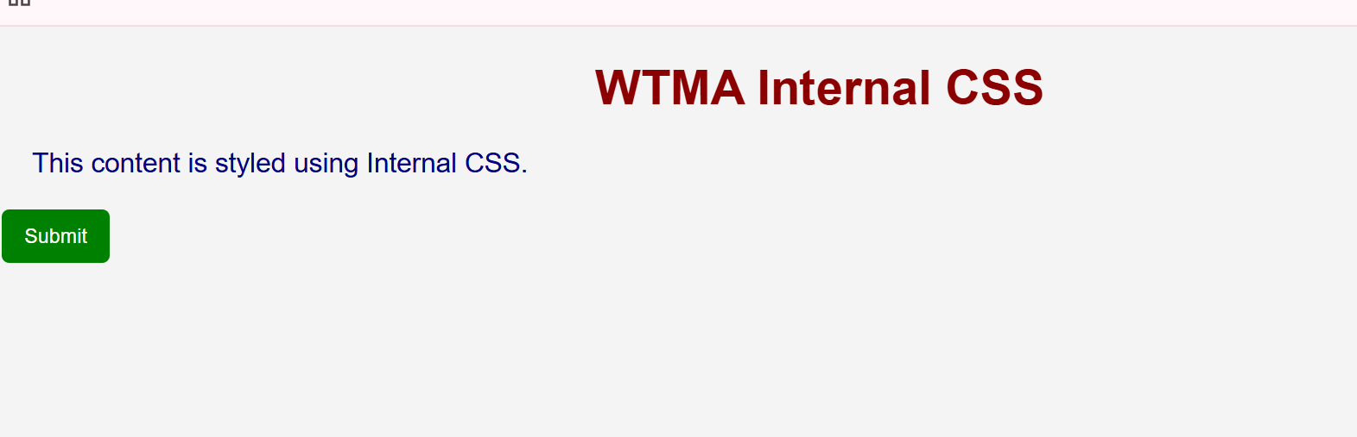
- External CSS applied through .css file


Result
Thus, Inline, Internal and External stylesheets were implemented and demonstrated successfully using CSS.

Program 2: Design a Student Record Web Page Using CSS Keyframe Animation

Aim
To design a Student Record webpage and apply CSS keyframe animation for text/card effects.

Software Required
- VS Code / Notepad++
- Browser: Chrome

Theory
CSS Keyframe Animation is used to create animations by defining key points of style changes over time.
Syntax:
@keyframes animationName {
0% { }
100% { }
}

Steps / Procedure
- Open VS Code / Notepad++.
- Create a new file and save as student_record_animation.html.
- Write the HTML structure for:
  - Student Record Title o Student details displayed using a <table>
- Create a container <div> with class card to show the student record.
- Inside <style> tag, apply CSS for:
  - body (background + center alignment) o card (width, padding, border-radius, shadow) o table (borders + spacing)
- Create keyframe animations using:
  - @keyframes slideIn (card comes from top with fade-in) o @keyframes glowText (title color glow effect)
- Apply animations using:
- animation: slideIn 2s ease; and animation: glowText 2s infinite alternate;
- Save the file.
- Run the HTML file in browser.
- Verify:
  - Card slides in smoothly o Title text glows continuously

Program Code

File: student_record_animation.html
<!DOCTYPE html>
<html>
<head>
<title>Student Record - Animation</title>
<style>
body { font-family: Arial, sans-serif; background: #f2f2f2; display: flex; justify-content: center; align-items: center; height: 100vh;
}

.card { width: 450px; padding: 25px; background: white; border-radius: 12px; box-shadow: 0px 0px 15px rgba(0,0,0,0.2); animation: slideIn 2s ease;
}

h2 { text-align: center; color: darkblue; animation: glowText 2s infinite alternate;
}

table { width: 100%; margin-top: 15px; border-collapse: collapse; }
td {
padding: 10px; border: 1px solid #ccc;
}

.label { font-weight: bold; background: #e0e0ff; width: 40%;
}

/* Keyframe Animations */ @keyframes slideIn {
from { transform: translateY(-60px); opacity: 0;
} to {
transform: translateY(0); opacity: 1;
}
}

@keyframes glowText {
from { color: darkblue; text-shadow: 0 0 5px skyblue;
} to { color: red; text-shadow: 0 0 10px orange;
}
}

</style>
</head>

<body>
<div class="card">
<h2>Student Record</h2>

<table>
<tr>
<td class="label">Student Name</td>
<td>Rahul Sharma</td>
</tr>
<tr>
<td class="label">Roll Number</td>
<td>CS101</td>
</tr>
<tr>
<td class="label">Course</td>
<td>B.Tech CSE</td>
</tr>
<tr>
<td class="label">Semester</td>
<td>4</td>
</tr>
<tr>
<td class="label">Email</td>
<td>rahul@gmail.com</td>
</tr>
<tr>
<td class="label">Phone</td>
<td>9876543210</td>
</tr>
</table>
</div>
</body>
</html>

Output
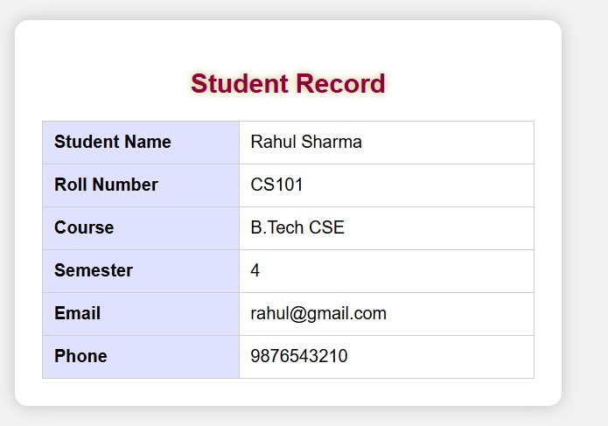

Result
Thus, a Student Record Web Page was designed and CSS keyframe animation was implemented successfully.

